

OPTIMIZATION ASSIGNMENT

Critical Path Method



December 19, 2023

Vansh Jain

2020A7PS0079U



Index

1. Critical Path Method (CPM)

2. Applications

2. Problem statement

3. Solution

4. Code and Implementation

5. Reference

1. Critical Path Method (CPM)

The Critical Path Method (CPM), also known as Critical Path Analysis (CPA) is a project management technique that provides a systematic approach to planning, scheduling, and overseeing complicated projects. A project is described as a group or network of connected tasks that require resources and time to complete. CPM has gained widespread usage in industries that depend heavily on project management, including engineering, construction, information technology, and other fields.

The fundamental purpose of CPM is to determine a project's critical path, or the order of tasks that must be finished on time in order to guarantee the project's success as a whole. Since the critical path is the one with the longest duration in the project, any delays in the tasks along it will have an immediate effect on when the project will be completed. Project managers must comprehend and control the critical path in order to guarantee timely delivery and effective resource allocation.

The first step in using CPM is to divide the project into individual tasks which is defined by its duration, dependencies, and resources required. A network diagram is used to visually represent tasks, which consists of nodes (tasks), arrows (dependencies between tasks) and arrow edge (resource or duration).

We then convert these associations into a network to represent the order relationships between the different tasks This flowchart provides a visual representation of the relationships and flow between different project activities.

The critical path is the longest path through the network diagram and consists of tasks that, if delayed, would directly impact the project's completion date. To find the critical path, we calculate the earliest start and finish times, as well as the latest start and finish times, for each task. The result in CPM is a time schedule for the project.

1. Applications

Because the Critical Path Method (CPM) is so effective at project planning, scheduling, and management, it is widely used in a wide range of industries and project types. The following are some important uses for the Critical Path Method:

* Construction Projects: CPM is used in construction to plan and schedule activities such as site preparation, foundation laying, structural work, and finishing. It helps identify the critical activities which could extend the project completion time and also enable better resource allocation.
* Research and Development: CPM is applied in R&D projects to manage the development of new products, technologies, or processes. It aids in optimizing research workflows and ensuring that project timelines are met.
* Research and Development: CPM is applied in R&D projects to manage the development of new products, technologies, or processes. It aids in optimizing research workflows, identifying bottlenecks, and ensuring that project timelines are met.

1. Problem

Imagine a construction project where various tasks need to be completed to construct a building. Each task has a specific duration, and some tasks depend on the completion of others. The goal is to optimize the project schedule to minimize the overall duration and identify the critical path.

|  |  |  |
| --- | --- | --- |
| ***Task*** | ***Duration (days)*** | ***Dependencies*** |
| Obtain Permits | 10 | - |
| Site Excavation | 5 | Obtain Permits |
| Foundation Laying | 15 | Site Excavation |
| Framing | 20 | Foundation Laying |
| Roofing | 10 | Framing |
| Plumbing | 15 | Foundation Laying |
| Electrical Wiring | 15 | Framing, Plumbing |
| Interior Finishing | 20 | Electrical Wiring |
| Painting | 10 | Interior Finishing |
| Landscaping | 15 | Roofing, Painting |
| Final Inspection | 0 | Landscaping |

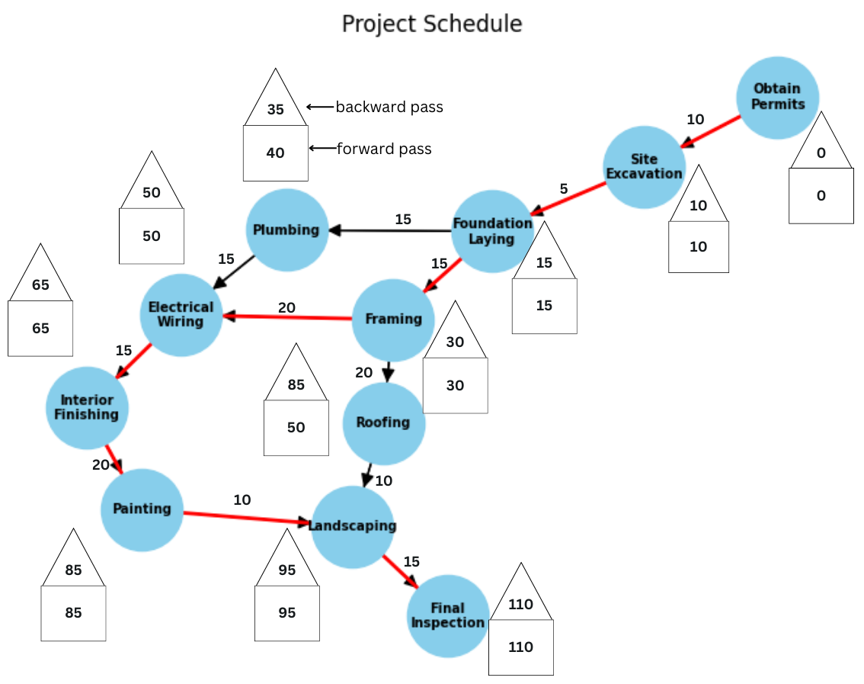

Figure – 1 Forward and backward pass calculations

Forward pass🡪

*Obtain Permits*: □Obtain Permits = 0

*Site Excavation*: □Site Excavation = □Obtain Permits + D (Obtain Permits, Site Excavation) = 0 + 10 = 10

*Foundation Laying*: □Foundation Laying = □Site Excavation + D (Site Excavation, Foundation Laying)) = 10 + 5 = 15

*Framing*: □Framing = □Foundation Laying + D (Foundation Laying, Framing) = 15 + 15 = 30

*Roofing*: □Roofing = □ Framing + D (Framing, Roofing = 30 + 20 = 50

*Plumbing*: □Plumbing = □Foundation Laying + D (Foundation Laying, Plumbing) =15+15 =30

*Electrical Wiring*: □Electrical Wiring = max (□Plumbing + D (Plumbing, Electrical Wiring), (□Framing + D (Framing, Electrical Wiring)) = max (30 + 15, 30 + 20) = 50

*Interior Finishing*: □Interior Finishing = □Electrical Wiring + D (Electrical Wiring, Interior Finishing) = 50 + 15 = 65

*Painting*: □Painting = □Interior Finishing + D (Interior Finishing, Painting) = 65 + 20 = 85

*Landscaping*: □Landscaping = max (□Roofing + D (Roofing, Landscaping), □Painting + D (Painting, Landscaping)) = max (50 + 10, 85 + 10) = 95

*Final Inspection*: □Final Inspection = □Landscaping + D (Landscaping, Final Inspection) = 95+ 15 = 110

**The computations show that the project can be completed in 110 days.**

Backward pass🡪

*Final Inspection*: □Final Inspection = 110 (This is the last task, so its latest start time is the same as its earliest start time)

*Landscaping*: □Landscaping = □Final Inspection - D (Landscaping, Final Inspection) = 110 - 15 = 95

*Painting*: □Painting = Landscaping - D (Painting, Landscaping= 95 – 10 = 85

*Interior Finishing*: □Interior Finishing = □Painting - D (Interior Finishing, Painting)=85-20=65

*Electrical Wiring*: □Electrical Wiring = □Interior Finishing - D (Electrical Wiring, Interior Finishing) = 65 - 15 = 50

*Plumbing*: □Plumbing = Electrical Wiring - D (Plumbing, Electrical Wiring) = 50 - 15= 35

*Roofing*: □Roofing = □ Landscaping - D (Roofing, Landscaping) = 95 - 10 = 85

*Framing*: □Framing = min (□Roofing - D (Framing, Roofing), □Electrical Wiring - D (Framing, Electrical Wiring)) = min (85 - 20, 50 - 20) = 30

*Foundation Laying*: □Foundation Laying = min (□Plumbing - D (Foundation Laying, Plumbing), □ Framing - D (Foundation Laying, Framing)) = min (35 - 15, 30 - 15) = 15

*Site Excavation*: □Site Excavation = □Foundation Laying - D (Site Excavation, Foundation Laying = 15 - 5= 10

*Obtain Permits*: □Obtain Permits = □Site Excavation - D (Obtain Permits, Site Excavation) = 10 - 10 = 0

1. Code

I have implemented the problem using the Python Programming language (3.11.5). All code can be found [here](https://github.com/vanshj22/Critical-Path-Method/tree/main).

Required Libraries 🡪

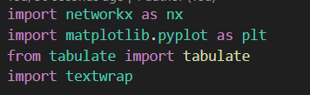

Function for storing data 🡪

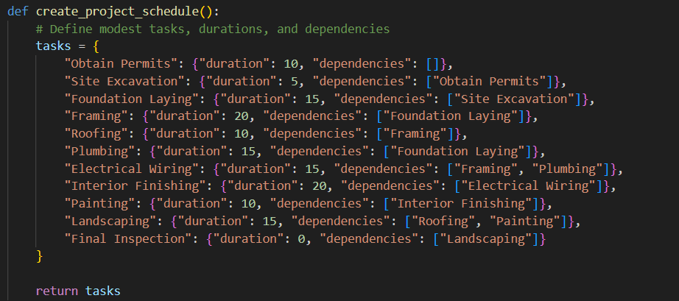

Function for finding the critical path using network library 🡪

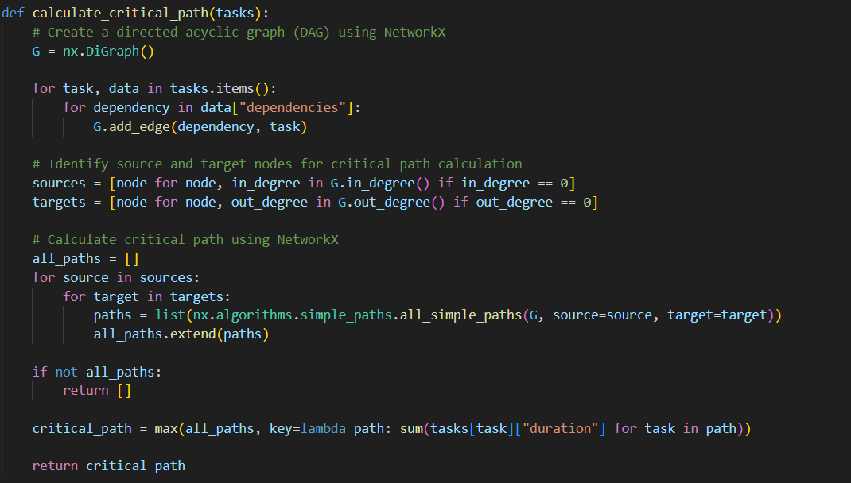

Function for plotting the critical path using network and matplotlib library 🡪

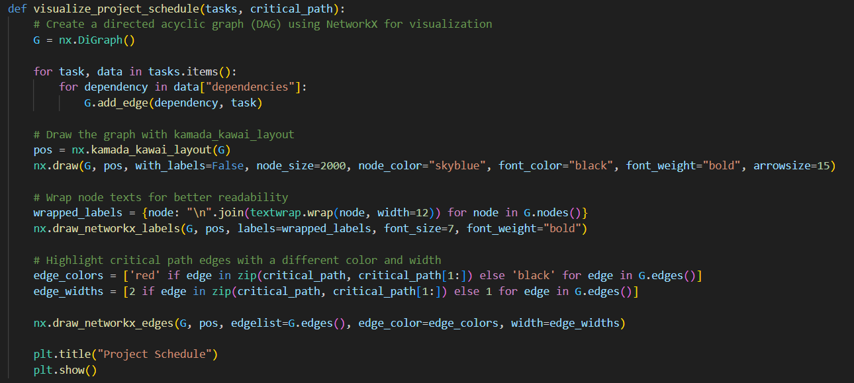

This is the main function where the final output is called 🡪

Output 🡪

+--------------------+-------------------+--------------------+

| Task | Duration (Days) | Dependencies |

+====================+===================+====================+

| Obtain Permits | 10 | - |

+--------------------+-------------------+--------------------+

| Site Excavation | 5 | Obtain Permits |

+--------------------+-------------------+--------------------+

| Foundation Laying | 15 | Site Excavation |

+--------------------+-------------------+--------------------+

| Framing | 20 | Foundation Laying |

+--------------------+-------------------+--------------------+

| Roofing | 10 | Framing |

+--------------------+-------------------+--------------------+

| Plumbing | 15 | Foundation Laying |

+--------------------+-------------------+--------------------+

| Electrical Wiring | 15 | Framing, Plumbing |

+--------------------+-------------------+--------------------+

| Interior Finishing | 20 | Electrical Wiring |

+--------------------+-------------------+--------------------+

| Painting | 10 | Interior Finishing |

+--------------------+-------------------+--------------------+

| Landscaping | 15 | Roofing, Painting |

+--------------------+-------------------+--------------------+

| Final Inspection | 0 | Landscaping |

+--------------------+-------------------+--------------------+

Critical Path:

- Obtain Permits

- Site Excavation

- Foundation Laying

- Framing

- Electrical Wiring

- Interior Finishing

- Painting

- Landscaping

- Final Inspection

Visualizing Project Schedule:

The red line shows the critical path.

1. Reference

* H.A.Taha, Operations Research: An Introduction, Pearson Education, 10th.edn, 2019.
* <https://www.geeksforgeeks.org/software-engineering-critical-path-method/>
* <https://www.workamajig.com/blog/critical-path-method#:~:text=%E2%80%9CThe%20Critical%20Path%20Method%20is,completed%20in%20a%20specific%20order>.
* <https://www.indeed.com/recruitment/c/info/critical-path-method-project-management>